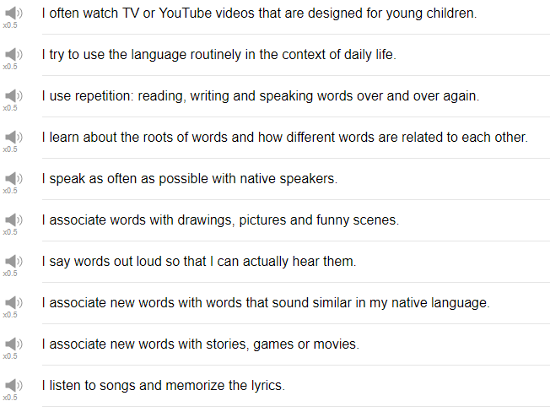

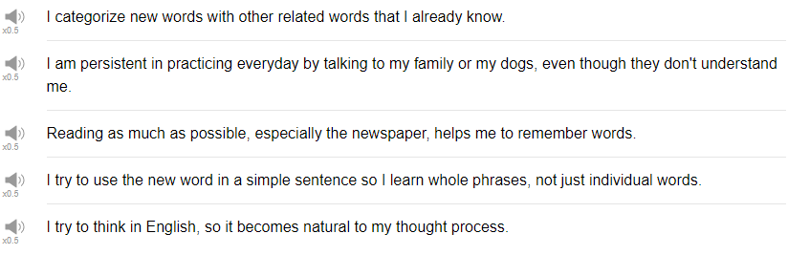

|  |
| --- |
| Hi, everybody! Welcome back to Top Words. My name is Alisha, and today we're going to talk about 10 different ways to remember words. So these are actually some ways to remember words that you have sent into us, so I'm really excited to see what your recommendations are! I study other languages, so let's talk about it! Let's see. |
| 1. I associate new words with words that sound similar in my native language. |
| If you're studying English, your native language might share some words. So, like, I'm studying Japanese, and for example the word "chocolate" sounds very very similar in Japanese. So in English the word is "chocolate", in Japanese the word is "chokoretto" so it sounds similar. So that's an easy word for me to remember. |
| 2. I learned about the roots of words and how different words are related to each other. |
| Many words in English have roots in very very old languages like Latin, so a word like omniscient, for example, can be broken down into maybe two parts: the omni-, omni meaning "all" or "everything"; and -scient, the "scient" part relates to "knowledge" or "knowing". So together the word means "all knowing", omniscient. And maybe you can guess the meaning even if it's the first time you've seen the word. Okay! |
| 3. I listened to songs and memorize the lyrics. |
| This is also a common way to to help kids learn things, too, through songs. Opposite of b, plus or minus the square root of b squared minus 4ac all over 2a. It's a quadratic function equation; because of the song, it's still in my head! Thank you Mrs. Syme. |
| 4. I often watch TV or YouTube videos that are designed for young children. |
| That's how children in the native language learn, so it's a great tool for you, don't be embarrassed to do that, I do that! In English, we have Dora the Explorer, we have Sesame Street, we have another channel that's made for children's content, but it could be useful for you, it's called Kids VS Life. So please be sure to check that out. |
| 5. I speak as often as possible with native speakers. |
| A native speaker can go, "ah! that's a strange thing that you're saying." So there are a lot of small factors that you can't get unless you're speaking with a native speaker, so this is a really really great tip. If you're interested in doing this with us, we have on EnglishClass101.com a special subscription which is called the elite level of subscription, where you get to actually study with one of our teachers here. So if you don't have somebody that you can study with now, that might be a way to do it. Please check that out if you're interested. |
| 6. I tried to use the language routinely in the context of daily life. |
| When you're alone, just doing stuff at home, like, making breakfast or cooking, or doing the laundry, if you use the language, just to say, like, now I'm going to, I don't know, cut vegetables, or Oh! I need to do laundry later today, or thinking about your appointment, whatever. Another good example is, really, I put my phone into my target language. You're telling little stories when you're having conversations with people, so get used to telling yourself the story. |
| 7. I use repetition reading, writing, and speaking words over and over again. |
| Keep repeating in your studies, even if it feels like, you know, you're not making any progress, you are just the act of doing that repetition can be helpful for you. If a football player never throws a football, he's not going to be able to throw it very well, is he? You have to repeat, repeat, repeat, and then when you're faced with the actual situation where you need to throw the football, you need to use that vocabulary word, you're ready, you already know how to say the word. So yes, repeat, it's good. |
| 8. I try to think in English so it becomes natural to my thought process. |
| I do this, I think about what I need to do, I think about what I have done, I think about what I'm going to do, and so in that way, you can practice past tense, future tense, and present tense. Recently this has been happening to me, I've started dreaming in Japanese from time to time, or I dream bilingually. It's exciting, I think. |
| 9. I tried to use the word in a simple sentence. |
| So I learned whole phrases, not just individual words. Yes, this is a huge tip! So vocabulary is important, of course. If you don't know a keyword you might miss the meaning of something, but context is important, too. So there might be two words which seemed very similar, like big and large, for example, but when should i use large? When should i use big? Like, if you're clothes shopping and you say "do you have this in a big-sized?" It might not be the correct way to use the word, instead, "do you have this in a large size?" is the correct phrase. so learning how to use the correct vocabulary word at the correct time is important, and you can do that through studying sentences and phrases instead of just vocabulary. This is why reading is important, i think. |
| 10.Reading as much as possible, especially the newspaper, helps me to remember words. |
| When i was a kid, i just read everything I was so into reading, I loved it! And I think that it helped, it actually helped my language skills improve even in my native language! Again, at first it's really hard to do and you might have to use a dictionary a lot, but you'll learn gradually more natural speaking patterns, more natural writing patterns, too, which will help you to sound more natural when you speak, and maybe it can help your listening skills, too. When you can listen for those patterns that you see in textbooks, that you see in newspapers and novels, whatever. It's a great tool, reading. |
| And thank goodness! That's the end! So those are 10 tips that you can use to remember new words and new phrases, try them out! I'm going to be doing my best with my target language, i hope that you do, too. Thank you very much for watching, please, please, please subscribe to our channel if you have not already, and we will see you again soon for more exciting information. Bye! |